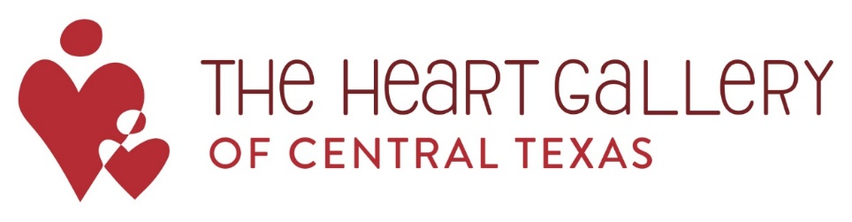

Heart Gallery of Central Texas Committee
2017-2018

Heart Gallery Program Components
- Annual REVEAL Event
- This is a free event and not a fundraiser. This year, it will be at the Blanton Museum on Thursday, November 9, 2017. The purpose will be to showcase the portraits, share the program’s mission, and bring awareness to how people can help going forward.
- Annual Mistletoe Jam
  - This is an annual PFC event focused on the Heart Gallery program and hosted by Byrd & Street. It held on the first Sunday in December and includes local Austin musicians coming together for an evening of music to benefit the Heart Gallery of Central Texas. This is the first year the Heart Gallery Committee will be charged with planning this event.
- Traveling Gallery Exhibits
- The portraits will be displayed at different venues around town (e.g., churches, businesses, museums, cafés, etc.) to bring awareness to the children needing homes and the program.
- Build and encourage relationships with professional photographers who volunteer their talents and time to photograph waiting children
- Build and expand relationships with businesses, organizations, and people who would like to participate in the traveling gallery exhibit or donate

Committee Membership
- One-year commitment (September 2017 – August 2018)
- Attend Orientation (Wednesday, August 23, 2017)
- Attend and help with logistics of the annual REVEAL event (Thursday, November 9, 2017)
- Attend 8 meetings throughout the year-- all at noon on Mondays at the Mitte Carriage House (12th & West St.) Lunch will be served at each meeting.
- The first meeting is September 11th, 2017 at 12:00pm, Mitte Carriage House
- Other 2017/2018 Meeting Dates:
    - 2017: October 9th, October 30th 2017, November 13th
    - 2018: January 8th, March 5th 2018, April 9th, May 14th 2018
- Serve in at least one of the following ways:
- Traveling Gallery Exhibit Coordinator - Contact businesses/venues about hosting a gallery and organize logistics. Ensure the exhibit runs smoothly throughout.
- Photographer Coordinator – Help plan 2-3 events to allow photographers to get information and network with other photographers.
- Media/Communication Representative – Help coordinate media events/updates and communications regarding the Heart Gallery.
- Match Party Support – Serve at 2-3 events to allow prospective adoptive parents and waiting children the opportunity to meet and spend time together. Match Parties are planned in coordination with the Department.
- Thank You Cards – Write thank you cards to venues for hosting and supporting the Heart Gallery. Thank you cards/envelopes are supplied by the Heart Gallery.
- Heart Gallery Support Coordinators – Contact Heart Gallery supporters to promote healthy relationships and opportunities for continued awareness and donations.
- REVEAL Admin- Assist in the prep and administrative task including RSVPs and preparing for REVEAL.
- Mistletoe Jam Lead-work closely with Elisabeth as the committee representative for the event, giving updates at committee meetings throughout the year.

